“Colour Detection Model”


COURSE PROJECT

Applied Electromechanics (ET1012)

FY B.Tech

Practical Batch No:-…..
Course Project Group ID:-

Submitted by Name of Batch In-charge
Prof Rahul Waikar
(ROLLNO) (Name)(PRN) DESH, VIT, Pune
1. (12) Aditi Patil (12411664)
2. (08) Abhishek Patil (12414243)
3. (11) Adit Pakhode (12412960)
4. (14) Aditya Kachwaha (12413066)

Vishwakarma Institute of Technology,Pune-411037
Sem I AY 2024-25

INDEX

CHAPTER | TITLEOFTHETOPIC | PAGENO.
NO.
1. | INTRODUCTION
 | What is the project? (Abstract). Significance of the topic | 1
 | What sort of work has been done till today in this regard?
 | Your work in brief.
2. | THEORY | 2
3. | CIRCUIT DESIGN, CODE AND SIMULATION  Code overview  Code implementation  Simulation | 2  3  5
4.  5. | Applications  RESULTS AND DISCUSSIONS | 6  6
6. | CONCLUSIONS | 7
 | REFERENCES

Report on Color Detection System Using TCS34725 Sensor

1. Introduction

What is the project? (Abstract)
The project involves creating a color detection system using the TCS34725 color sensor. The system reads the RGB values from the sensor and compares them to predefined color ranges. The detected color is displayed on an LCD screen, and a buzzer is used to provide audible feedback when a color is identified. This system demonstrates how sensors can be integrated with microcontrollers to create interactive applications that respond to environmental inputs, such as color.

Significance of the topic
Color detection has numerous applications in fields like robotics, manufacturing, and sorting systems. The ability to identify colors automatically allows for the automation of tasks such as sorting objects, quality control, and even simple interactive systems. This project provides a low-cost, easy-to-understand system that can be used as a foundation for more complex applications in color recognition.

What sort of work has been done till today in this regard?
Several systems and projects have been built around color detection, using various color sensors, including the TCS3200, TCS34725, and others. These systems have been employed in applications ranging from simple educational projects to industrial color sorting machines. While color sensors like the TCS34725 offer high accuracy, much research has been devoted to improving the reliability of these systems, especially under varying lighting conditions.

Your work in brief
This project uses the TCS34725 color sensor to detect the color of objects based on the raw RGB data. The detected color is matched with predefined color ranges, displayed on an LCD, and an audible feedback is provided through a buzzer. The system does not rely on an RGB LED and focuses on providing a simple yet effective approach for color identification.

2. Theory
The TCS34725 color sensor works by detecting the amount of red, green, blue, and clear light reflecting from an object. It uses an array of photodiodes filtered to sense these specific colors, and the sensor outputs four channels of data: red, green, blue, and clear. These data points are used to compute the relative intensity of each color, which is then used to identify the detected color by comparing the values to predefined ranges for each color.
The system uses the following process:
- Sensor Data Collection: The raw RGB and clear values are read from the sensor.
- Color Processing: The RGB values are normalized to produce relative color intensities.
- Color Matching: The normalized values are compared with predefined color ranges to identify the color.
- Display and Feedback: The detected color is displayed on an LCD screen, and the buzzer emits a tone when a color is detected.

3. Circuit Design, Code, and Simulation

Circuit Design
The following components are used in the circuit:
- TCS34725 Color Sensor:
  - Connected to the Arduino via I2C (SDA and SCL pins).
- Buzzer:
  - Connected to pin 9 on the Arduino to provide an audible alert when a color is detected.
- LCD (16x2 I2C):
  - Connected to the Arduino via I2C to display the detected color.
- Arduino Uno:
  - The central microcontroller, which processes the sensor data and controls the LCD and buzzer.

Code Overview
The code for the system includes several key sections:
- Libraries:
  - Wire.h: For I2C communication.
  - Adafruit_TCS34725.h: For controlling the TCS34725 color sensor.
  - LiquidCrystal_I2C.h: For controlling the LCD over I2C

- Setup:
  - Initializes the LCD display, buzzer, and TCS34725 color sensor.
  - The sensor is configured to measure colors with a gain of 4x and an integration time of 50 ms.
- Color Detection Logic:
  - The sensor's raw RGB and clear values are read, averaged, and scaled to produce RGB values.
  - The RGB values are compared to predefined color ranges to identify the color.
- Output:
  - The detected color is displayed on the LCD.
  - The buzzer is activated when a color is detected and deactivated if no color is recognized.
Code Implementation:
#include <Wire.h>
#include <Adafruit_TCS34725.h>
#include <LiquidCrystal_I2C.h>

LiquidCrystal_I2C lcd(0x27, 16, 2);
#define buzzer 9 // Buzzer connected to pin 9

Adafruit_TCS34725 tcs = Adafruit_TCS34725(TCS34725_INTEGRATIONTIME_50MS, TCS34725_GAIN_4X);

// Color calibration data
struct ColorData {
String name;
int rMin, rMax, gMin, gMax, bMin, bMax;
};

ColorData colors[] = {
{"RED", 180, 255, 0, 60, 0, 60},
{"ORANGE", 150, 255, 50, 150, 0, 80},
{"GREEN", 0, 90, 130, 255, 0, 90},
{"BLUE", 0, 100, 0, 100, 100, 255},
{"BLACK", 0, 50, 0, 50, 0, 50},
{"WHITE", 200, 255, 200, 255, 200, 255},
{"BROWN", 80, 150, 50, 100, 0, 50},
{"YELLOW", 150, 255, 150, 255, 0, 80}
};
int numColors = sizeof(colors) / sizeof(colors[0]);

void setup() {
Serial.begin(9600);
lcd.init();
lcd.backlight();
pinMode(buzzer, OUTPUT);

if (tcs.begin()) {
Serial.println("TCS34725 found");
} else {
Serial.println("No TCS34725 found ... check your connections");
while (1);
}
}

void loop()
{
uint16_t r, g, b, clear;

uint32_t rSum = 0, gSum = 0, bSum = 0, clearSum = 0;

// Take multiple readings to get average values
for (int i = 0; i < 10; i++) {
tcs.setInterrupt(false);
delay(60);
tcs.getRawData(&r, &g, &b, &clear);
tcs.setInterrupt(true);
rSum += r;
gSum += g;
bSum += b;
clearSum += clear;
delay(10);
}

r = rSum / 10;
g = gSum / 10;
b = bSum / 10;
clear = clearSum / 10;
if (clear == 0) clear = 1;

float red = (r / (float)clear) * 255;
float green = (g / (float)clear) * 255;
float blue = (b / (float)clear) * 255;

Serial.print("R: "); Serial.print(int(red));
Serial.print("\tG: "); Serial.print(int(green));
Serial.print("\tB: "); Serial.println(int(blue));

String detectedColor = "UNKNOWN";

// Compare the detected color with predefined color ranges
for (int i = 0; i < numColors; i++) {
if (red >= colors[i].rMin && red <= colors[i].rMax &&
green >= colors[i].gMin && green <= colors[i].gMax &&
blue >= colors[i].bMin && blue <= colors[i].bMax) {
detectedColor = colors[i].name;
break;
}
}

// Display the detected color on the LCD
lcd.clear();
lcd.setCursor(2, 0);
lcd.print("COLOR DETECTED!");
lcd.setCursor(3, 1);
lcd.print("COLOR: ");
lcd.print(detectedColor);

// Activate the buzzer if a color is detected
if (detectedColor != "UNKNOWN") {
tone(buzzer, 1000, 500); // Emit a tone for 500ms
} else {
digitalWrite(buzzer, LOW);
}

delay(1000);
}

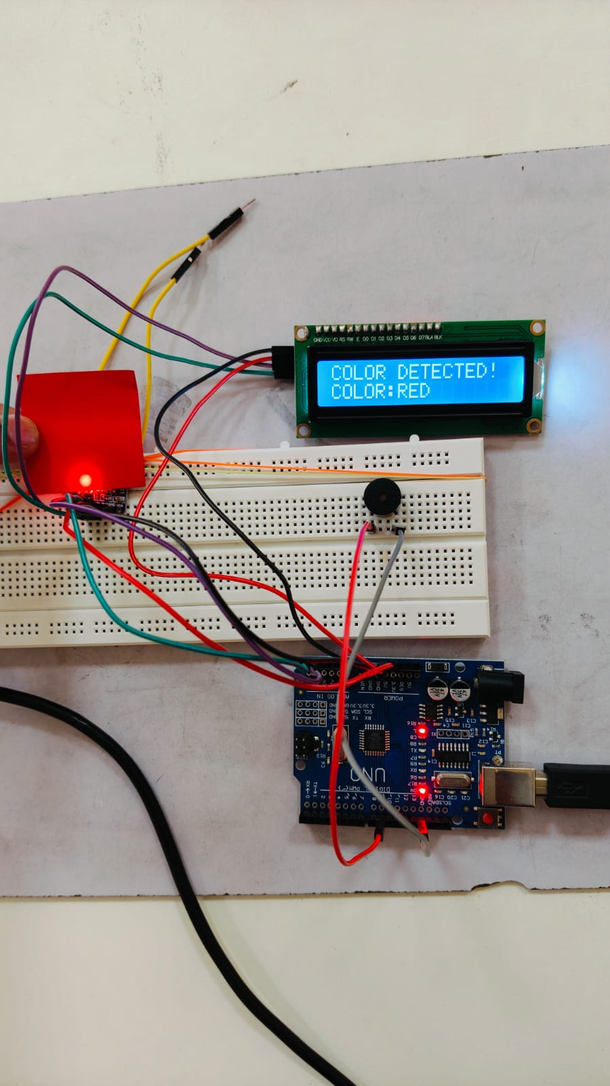

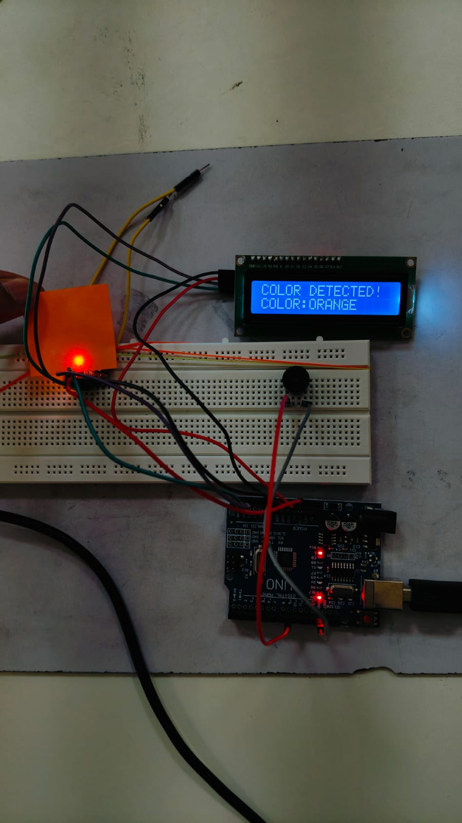

4. Applications
The color detection system has numerous potential applications in various fields:
- Sorting and Classification:
  - The system can be used in industrial settings to sort objects based on their color. For example, sorting fruits, vegetables, or products on a production line based on color.
- Quality Control:
  - In manufacturing, this system can automatically detect defects in products, such as wrong color matching or stains, ensuring only high-quality products are shipped.
- Robotics:
  - Robots can be equipped with color detection systems to navigate environments, interact with objects, or perform tasks like picking up specific colored items from a shelf.
- Interactive Systems:
  - The system can be integrated into educational tools or interactive displays, where users can input objects of different colors, and the system provides feedback, such as identifying the color or performing actions based on the color.
- Assistive Technology:
  - This technology can be used in assistive devices for people with visual impairments to identify colors of objects in their environment.
- Color-Based Automated Systems:
  - The system can be incorporated into automatic lighting systems where the detected color can influence the lighting conditions, such as adjusting the color of lights in response to the detected color.

5. Results and Discussions

Key Observations:
- Color Detection Accuracy: The system accurately detects basic colors such as red, green, blue, yellow, and others. The detection is reliable in most lighting conditions, though ambient light may affect results.
- Display and Feedback: The detected color is displayed clearly on the LCD screen, and the buzzer gives immediate audible feedback when a valid color is detected.
- Limitations: Some colors may be difficult to distinguish in the presence of highly reflective surfaces or under strong ambient light conditions. Calibration may be necessary for specific environments

6. Conclusions
The color detection system using the TCS34725 sensor is an effective solution for basic color recognition. The system provides both visual and auditory feedback, making it suitable for simple automation tasks or educational purposes. While the system works well in typical environments, improvements can be made by adapting the calibration process to account for varying lighting conditions.

